Unequal Sides
# Source: AI Source: Provided by: [Data Path: Persons Table -> ID Column: 1, Name_En Column: Motasem Essam] -> From: [ChatGPT] on [7/25/2026]
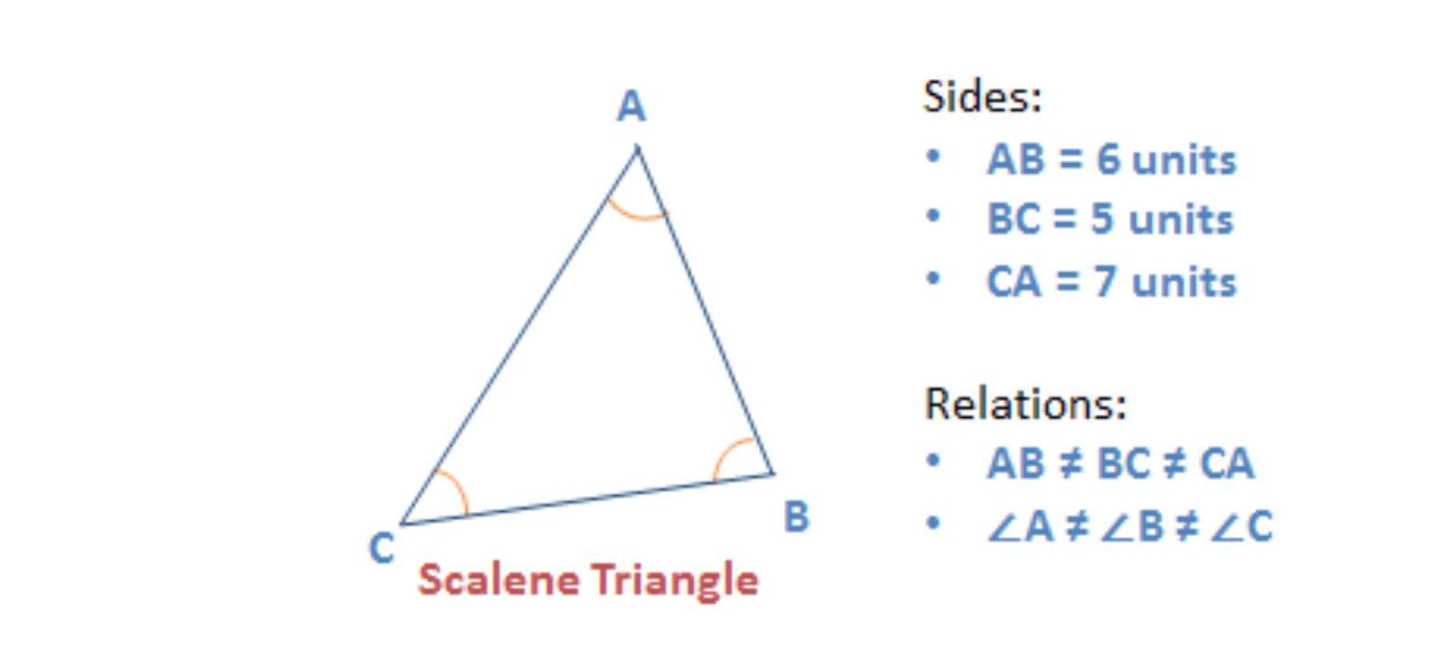
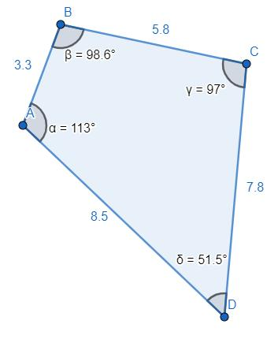
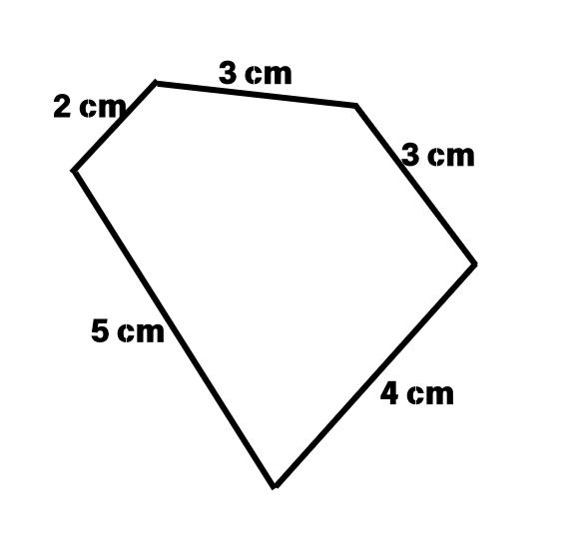
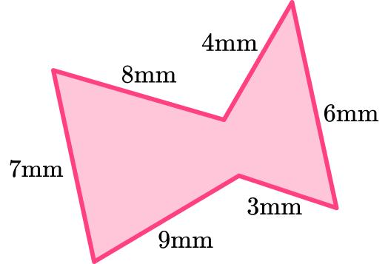
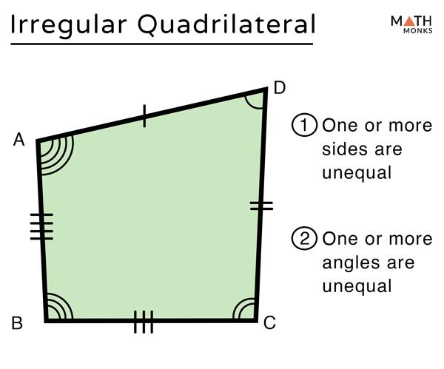
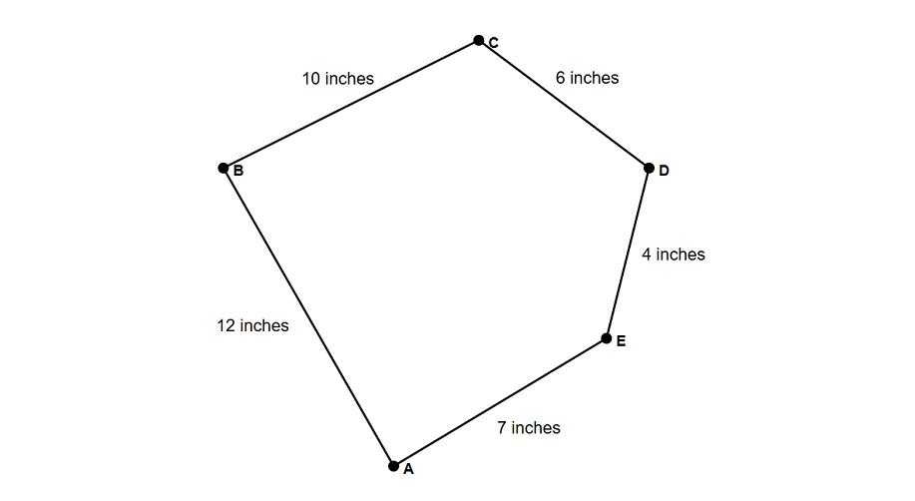
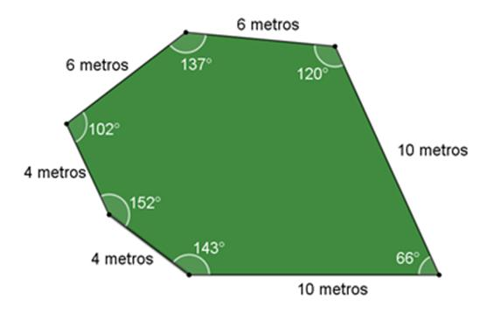

Definition
# Source: AI Source: Provided by: [Data Path: Persons Table -> ID Column: 1, Name_En Column: Motasem Essam] -> From: [ChatGPT] on [7/25/2026]
Unequal Sides are two or more sides of the same geometric figure that have different lengths. Unlike equal (congruent) sides, no two or not all of the sides are identical in length.
Unequal sides are commonly found in irregular polygons and in figures such as scalene triangles.

Characteristics
# Source: AI Source: Provided by: [Data Path: Persons Table -> ID Column: 1, Name_En Column: Motasem Essam] -> From: [ChatGPT] on [7/25/2026]
Unequal sides:
- Have different lengths.
- Are not congruent.
- May be adjacent or opposite.
- Are common in irregular geometric figures.
- Affect the shape's symmetry and classification.

Illustration

Scalene Triangle
# Source: AI Source: Provided by: [Data Path: Persons Table -> ID Column: 1, Name_En Column: Motasem Essam] -> From: [ChatGPT] on [7/25/2026]
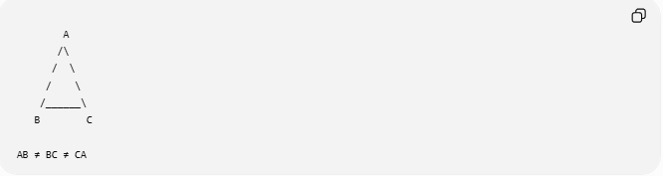
A
/\
/ \
/ \
/______\
B C

AB ≠ BC ≠ CA
All three sides have different lengths.

Irregular Quadrilateral
# Source: AI Source: Provided by: [Data Path: Persons Table -> ID Column: 1, Name_En Column: Motasem Essam] -> From: [ChatGPT] on [7/25/2026]
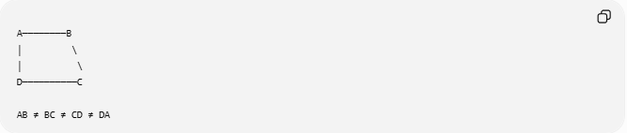
A────────B
│ \
│ \
D──────────C

AB ≠ BC ≠ CD ≠ DA
The four sides have different lengths.

Mathematical Representation
# Source: AI Source: Provided by: [Data Path: Persons Table -> ID Column: 1, Name_En Column: Motasem Essam] -> From: [ChatGPT] on [7/25/2026]
If two sides have different lengths:
$$\overline{AB}≠\overline{CD}$$
For a scalene triangle:
$$\overline{AB}≠\overline{BC}$$
$$\overline{BC}≠\overline{CA}$$
$$\overline{CA}≠\overline{AB}$$

Examples
# Source: AI Source: Provided by: [Data Path: Persons Table -> ID Column: 1, Name_En Column: Motasem Essam] -> From: [ChatGPT] on [7/25/2026]
Example 1 – Scalene Triangle
All three sides are different.

Example 2 – Irregular Pentagon
Each side may have a unique length.

Example 3 – Irregular Hexagon
Most irregular hexagons contain unequal sides.

Shapes with Unequal Sides
# Source: AI Source: Provided by: [Data Path: Persons Table -> ID Column: 1, Name_En Column: Motasem Essam] -> From: [ChatGPT] on [7/25/2026]
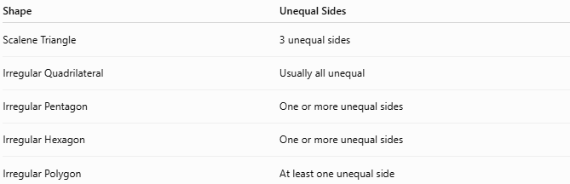
Shape | Unequal Sides
Scalene Triangle | 3 unequal sides
Irregular Quadrilateral | Usually all unequal
Irregular Pentagon | One or more unequal sides
Irregular Hexagon | One or more unequal sides
Irregular Polygon | At least one unequal side

Properties
# Source: AI Source: Provided by: [Data Path: Persons Table -> ID Column: 1, Name_En Column: Motasem Essam] -> From: [ChatGPT] on [7/25/2026]
1. No Congruence
Unequal sides are not congruent.

2. Reduced Symmetry
Figures with unequal sides usually have fewer or no lines of symmetry.

3. Shape Classification
Unequal sides help identify:
- Scalene triangles.
- Irregular polygons.

4. Angle Relationships
In many polygons, unequal sides are often associated with unequal interior angles.

Real-World Examples
# Source: AI Source: Provided by: [Data Path: Persons Table -> ID Column: 1, Name_En Column: Motasem Essam] -> From: [ChatGPT] on [7/25/2026]
Unequal sides appear in:
- Irregular land plots.
- Mountain outlines.
- Natural rocks.
- Architectural floor plans.
- Decorative patterns.
- Road intersections.
- Custom furniture.
- Irregular windows.

Applications
# Source: AI Source: Provided by: [Data Path: Persons Table -> ID Column: 1, Name_En Column: Motasem Essam] -> From: [ChatGPT] on [7/25/2026]
Unequal sides are used in:
- Plane Geometry
- Coordinate Geometry
- Engineering
- Architecture
- Surveying
- GIS (Geographic Information Systems)
- CAD (Computer-Aided Design)
- Computer Graphics
- Robotics
- Industrial Design

Advantages
# Source: AI Source: Provided by: [Data Path: Persons Table -> ID Column: 1, Name_En Column: Motasem Essam] -> From: [ChatGPT] on [7/25/2026]
Studying unequal sides helps to:
- Classify polygons.
- Analyze irregular figures.
- Solve geometric problems involving side lengths.
- Model real-world objects more accurately.
- Understand relationships between sides and angles.

Limitations
# Source: AI Source: Provided by: [Data Path: Persons Table -> ID Column: 1, Name_En Column: Motasem Essam] -> From: [ChatGPT] on [7/25/2026]
Unequal sides:
- Do not uniquely determine a shape.
- Often require additional angle or side information to identify a figure completely.

Comparison with Related Concepts
# Source: AI Source: Provided by: [Data Path: Persons Table -> ID Column: 1, Name_En Column: Motasem Essam] -> From: [ChatGPT] on [7/25/2026]
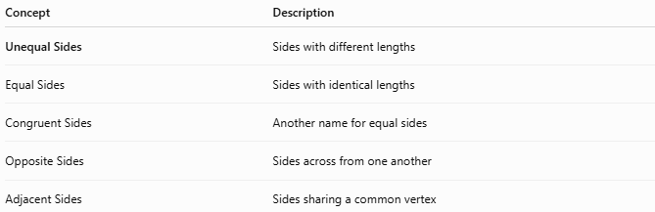
Concept | Description
Unequal Sides | Sides with different lengths
Equal Sides | Sides with identical lengths
Congruent Sides | Another name for equal sides
Opposite Sides | Sides across from one another
Adjacent Sides | Sides sharing a common vertex

Key Points
# Source: AI Source: Provided by: [Data Path: Persons Table -> ID Column: 1, Name_En Column: Motasem Essam] -> From: [ChatGPT] on [7/25/2026]
- Unequal Sides have different lengths.
- They are not congruent.
- Common examples include:
  - Scalene triangles.
  - Irregular quadrilaterals.
  - Irregular polygons.
- Unequal sides often reduce symmetry and help classify irregular figures.

Conclusion
# Source: AI Source: Provided by: [Data Path: Persons Table -> ID Column: 1, Name_En Column: Motasem Essam] -> From: [ChatGPT] on [7/25/2026]
Unequal Sides are sides of a geometric figure that do not have the same length. They are a defining feature of many irregular polygons and scalene triangles, helping distinguish these figures from regular or congruent-sided shapes. Unequal sides are fundamental in plane geometry, coordinate geometry, engineering, architecture, surveying, CAD, GIS, computer graphics, robotics, and industrial design, where they are used to analyze irregular figures, describe real-world objects, and solve geometric problems involving varying side lengths.

